MEMORANDUM

Date: February 21, 2025
To: Clinically Responsible Service Providers (CRSP)
From: Melissa Moody MS, LLP, MBA- VP of Clinical Operations
Re: DWIHN Website Update- General Fund Benefit Plan

Detroit Wayne Integrated Health Network (DWIHN) is pleased to inform you that we have added a Utilization Management General Fund link on our DWIHN website. https://www.dwihn.org/utilization-management. This will allow our provider network easier access to the most up-to-date General Fund Benefit Plan and related information. This link can be located under the Utilization Management information page. Please see the attached for website location information.

General Fund Exception is the process designed to prevent the interruption of needed services while the insurance acquisition/reinstatement is completed. For a member to be considered for General Fund Exception to cover the cost of services, the CRSP must first confirm the insurance status, then electronically complete and submit the "Requests for General Fund Exception." General Fund authorization approvals are completed on a case-by-case basis and will not exceed 60 days without an exception approval. Personal Care and/or Community Living Supports will not exceed 30 days.

If you have any question please reach out to Marlena Hampton, Utilization Management Director, at mhampton@dwihn.org Thank you.

Sincerely,
Melissa Moody MS, LLP, MBA
VP of Clinical Operations

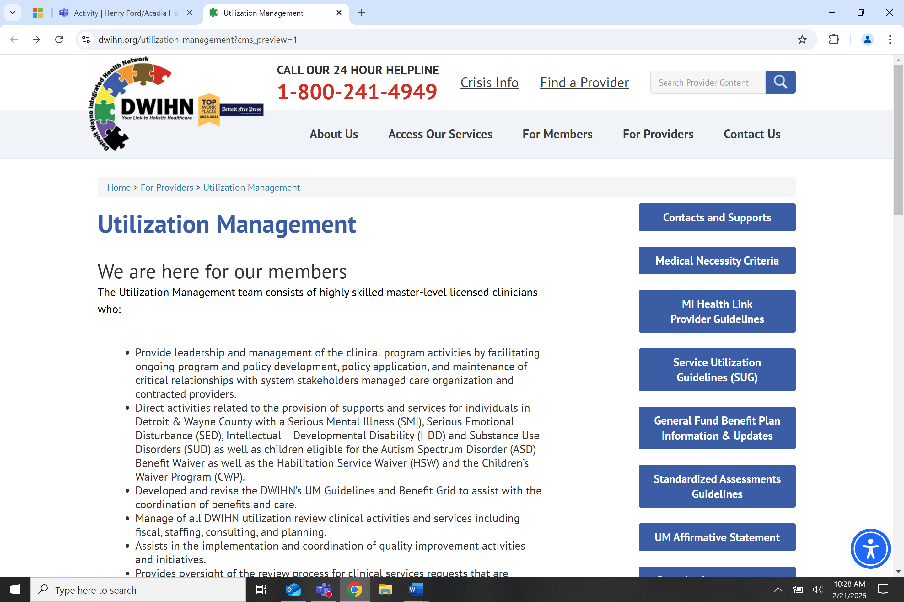

General Fund Benefit Plan Covered Services
Service Description | HCPCS &  Revenue Codes | Reporting Code Description
Assessments | 90791 | Psychiatric Evaluation
Assessments | 90792
Assessments | 9079x
Assessments | H0031 | Assessment (CAFAS/PECFAS – SEDW only)
Assessments | H0002 | Brief Screening to a Non-Inpatient Program
Assessments | T1023 | Screening for an Inpatient Program
 | 96110 | Assessment (H0031 replacement code)
Behavioral Treatment Plan Review | H2000 | Comprehensive Multidisciplinary Evaluation
Crisis Intervention | H2011 | Crisis Intervention Service
Crisis Residential Unit | H0018 | Crisis Residential Unit Services
Intensive Crisis Stabilization | S9484 | Crisis Intervention Mental Health Services, Per Hour. DCH-Approved Program Only
Misc Therapeutic Items & Supplies | T1999 | Includes Genoa Medication Assistance
Medication Administration | 99506 | Provided by physician, licensed PA, NP, RN, or LPN assisting a physician
Medication Administration | 96372
Med Drop | H2015 PH | Med Drop Services
Medication Review | 99201-99215 | Psychiatric Evaluation and medication management require very specific Medical Necessity Criteria detailed documentation to support service utilization.
Medication Review | 992xx
Services for Individuals on  AOT, NGRI Status, Jail Diversion | -- | Services necessary to meet AOT or NGRI  Requirements
Outpatient Services | 9083x | Outpatient Therapy Services- Up to 2/month
Targeted Case Management | T1017 | Up to 4 units per month
Treatment Planning | H0032 | Mental Health Service Plan development by non-physician.
Specialized Residential  (Authorized up to  30 days) | H2016 | Comprehensive Community Living Support Services in Specialized Residential Setting
Specialized Residential  (Authorized up to  30 days) | H2x15 | Comprehensive Community Living Support Services in Unlicensed Residential Setting and staffing services
Specialized Residential  (Authorized up to  30 days) | T2x27 | Overnight Health and Safety Supports in specialized unlicensed homes and staffing services
Specialized Residential  (Authorized up to  30 days) | T1020 | Personal Care in licensed Specialized Residential Setting

*Revised 2-21-25

