Description of DWIHN Population Health and what it does
(example: https://www.ihi.org/library/blog/populations-population-health-and-evolution-population-management-making-sense-terminology)
DWIHN seeks to assess and improve the health of its Membership, monitor the health of its potential population (Medicaid-eligible people living within Wayne County), and measure how the health of these populations compares to the health of the Wayne County and State of Michigan populations.
Links to public-facing population health assessment and population health management strategy documents (example: https://www.bcbst.com/docs/providers/quality-initiatives/PQ_MA_Population_Health.pdf
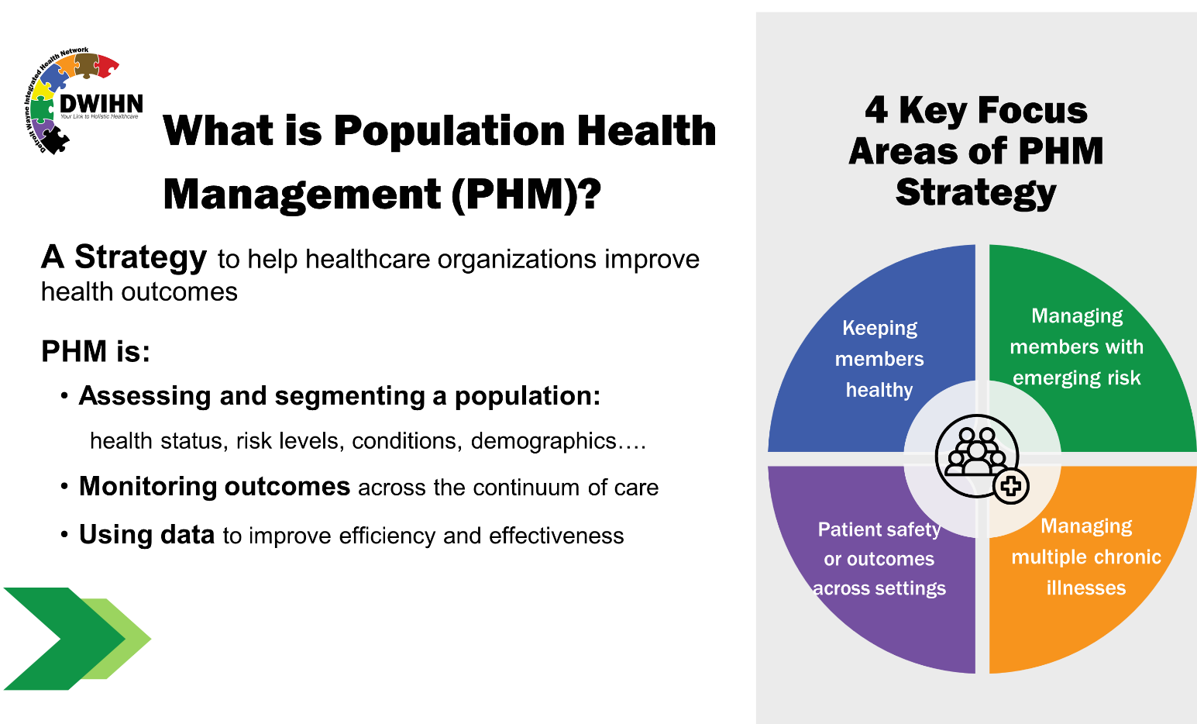

Mental Health Equity and DWIHN's commitment
(example: https://www.aetnabetterhealth.com/michigan/providers/health-equity.html)
At DWIHN, we believe that every individual should have a fair and equal opportunity to be as healthy – physically and mentally – as possible. Many communities within Wayne county face unique barriers to mental and physical health. Health equity means identifying and recognizing these barriers and establishing programs and supports to counteract these challenges.

What are the social determinants of health?
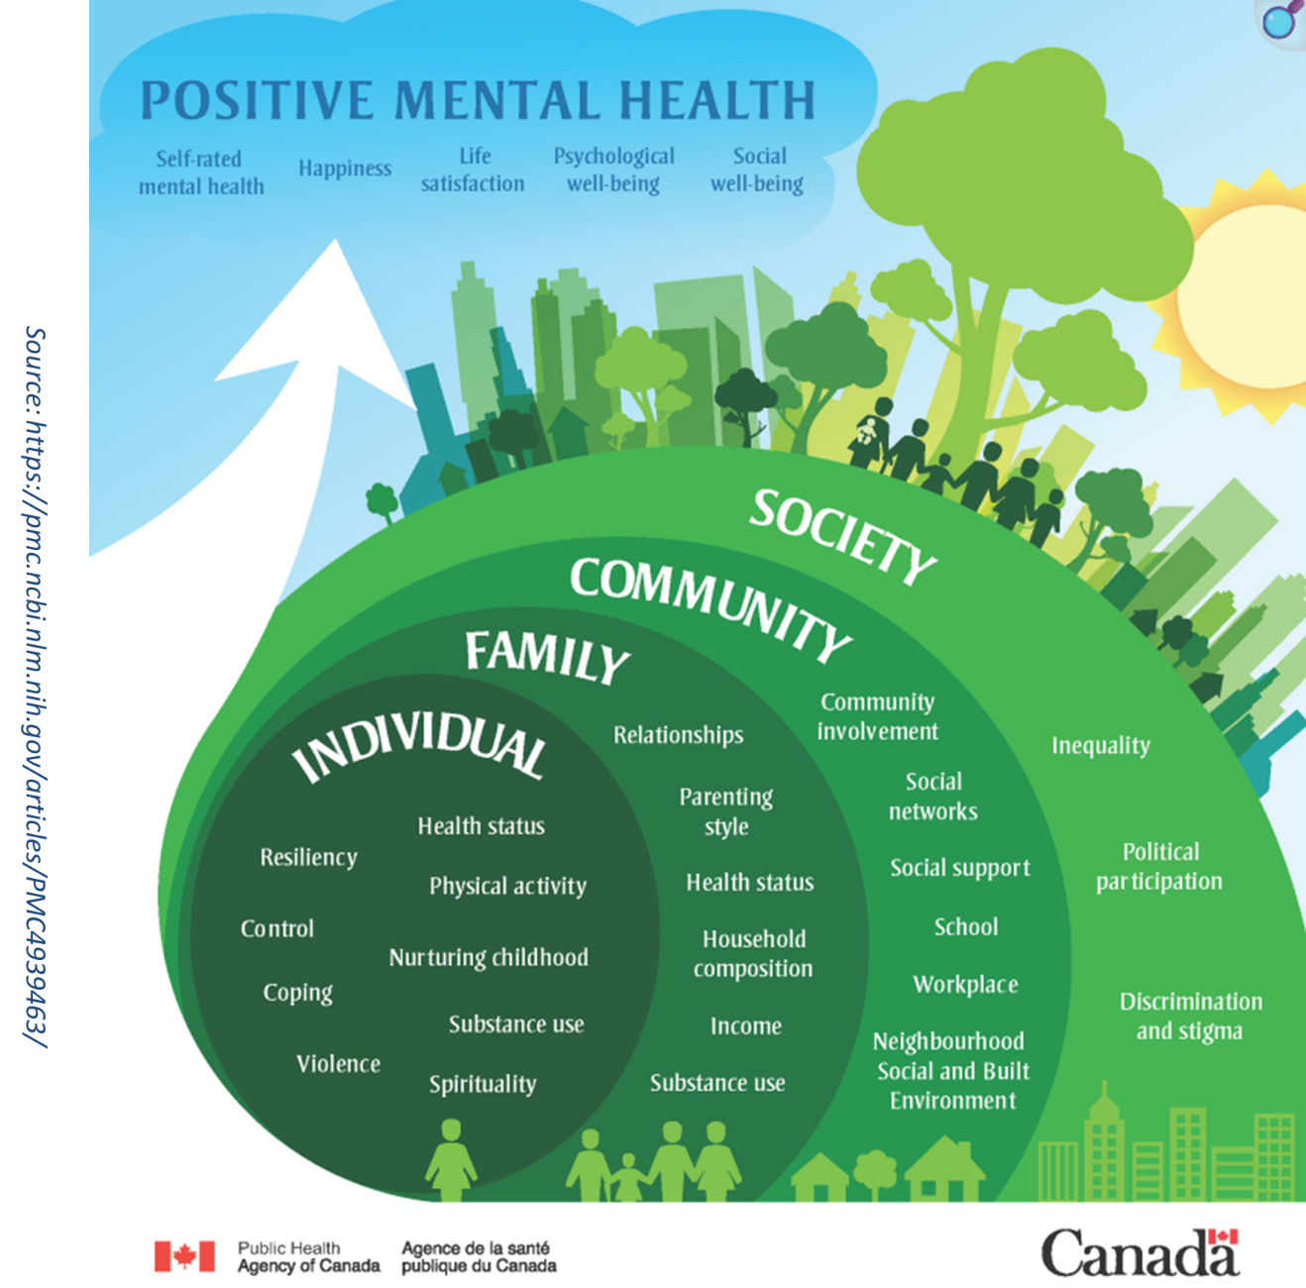

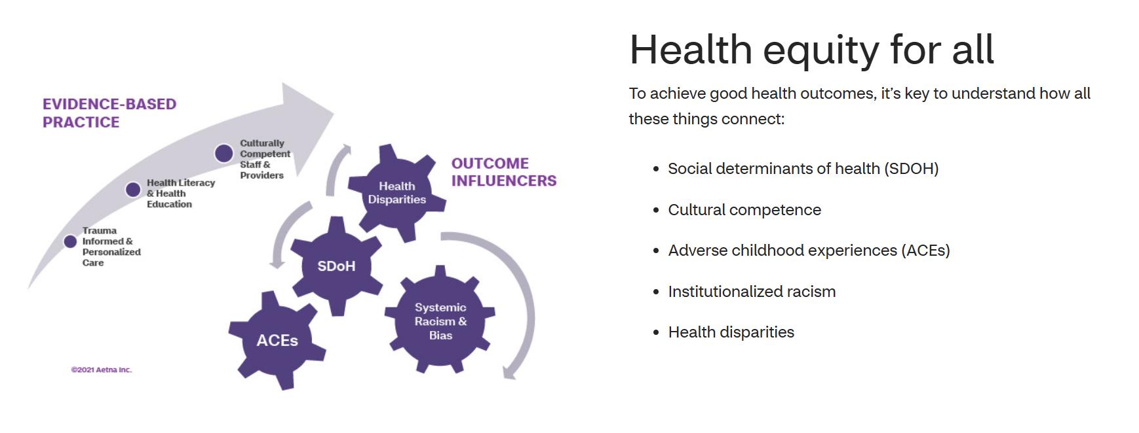
(note: this is Aetna’s copyrighted diagram, need to adapt to our use)

Current DWIHN programs to reduce inequity (add links)
1)
2)
…..

